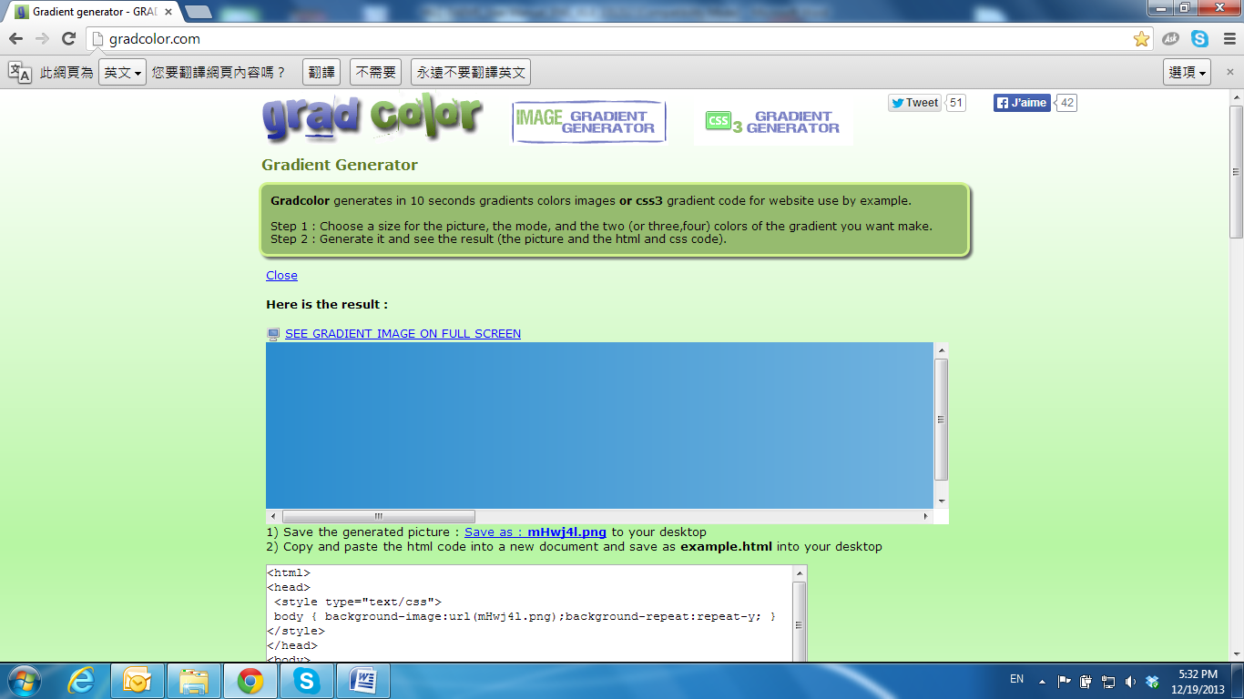

Hardware Installation

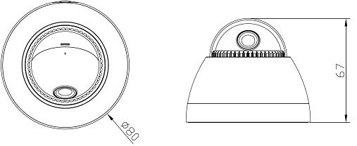

**1. Placing the Camera**

Cable from the bottom

a. Use the provided inside the accessories package to lock the base of camera on the ceiling or wall.

b. Put the cover back, and turn it tightly to preserve the IP.

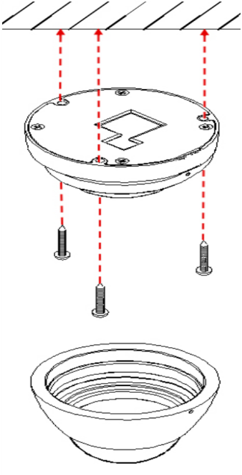

Side Cable

a. Find a conversion ring and two screws inside the accessories package.

b. Use the screws to lock the conversion ring on the ceiling or wall.

c. Use the screws to join the base of the camera with the conversion ring. The cable must pass through the hole on the side of the conversion ring.

d. Put the cover back, and turn it tightly to preserve the IP.

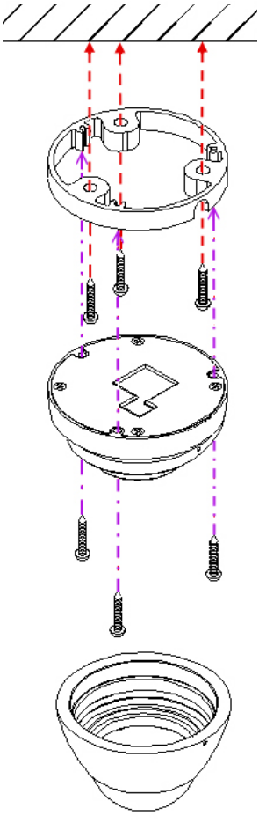

**2. After removing the dome cover, you will see the Micro SD card slot and the reset button.**

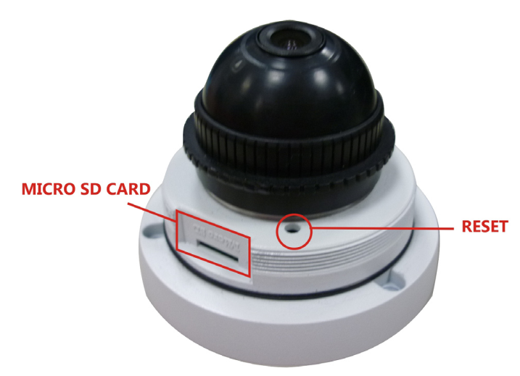

After opening the front cover, install the IP Camera and put the cover back within 10 minutes for avoiding fog in the IP Camera Housing.

**3. Connectors**

Connect the power adaptor first, then connect the IP Camera to the PC or network, and set up the network configurations according to the network environment.

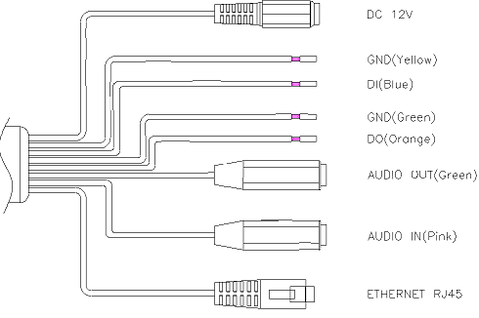

**4. PoE (Power Over Ethernet) (Optional) 802.3af, 15.4W** PoE Switch is recommended

Power over Ethernet (PoE) is a technology that integrates power into a standard LAN infrastructure. It allows providing power to a network device, such as an IP phone or a network camera, using the same cable as that used for network connection. It eliminates the need for power outlets at the camera locations and enables easier application of uninterruptible power supplies (UPS) to ensure 24 hours a day, 7 days a week operation.

